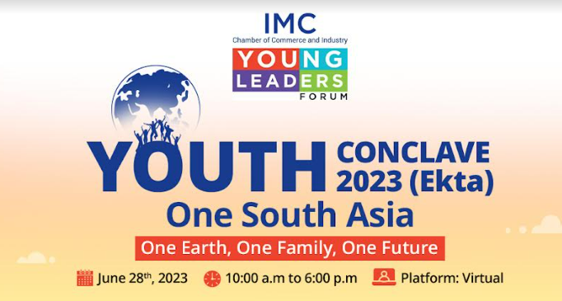**YOUTH CONCLAVE 2023 (Ekta) One South Asia** |**One Earth,One Family, One Future**

Wednesday June 28, 2023 from 10:00 a.m. to 6:00 p.m.

**Dear Sir/ Madam,**

We are pleased to inform you that the **3rd IMC Youth Conclave** is being organised on online platform by **Young Leaders’ Forum (IMC-YLF) of IMC** on **June 28, 2023 from 10:00 am to 6:00 p.m.** This year being India’s Presidency of G-20, the theme we have chosen is **“(EKTA) One South Asia |One Earth, One Family, One Future.**”

In order to facilitate participation from all across India and South Asia, the Conclave is being hosted on a 3D online platform which will give you the feel of being physically present in an auditorium.

As India is working on a vision to bring the whole world together for a common objective, for a better future, this year’s **IMC-YLF Youth Conclave** will bring together youth and young entrepreneurs as well as students from across South Asia on one (virtual) platform to discuss G20 themes and to use India's and global South Asian experiences, learnings, and models as templates for global solutions.

**IMC-YLF Annual Youth Conclave** was established with a motivating message from the Hon’ble Prime Minister Shri Narendra Modi in 2021, it is designed to complement the efforts of the Government of India to harness and channelize the energies of the youth. Since then a personally signed Message from Honourable Prime Minister has been a cornerstone of IMC-YLF Youth Conclave. We have had more than 4000 participants including young entrepreneurs and students from more than 50 institutes across India and abroad in 2021 and 2022 editions of IMC-YLF Youth Conclave.

The unique feature of this year’s Youth Conclave is a **Social Fiction Competition (Imagining the Future)** for students from pan-India colleges as well as South Asian international institutes and universities to showcase their creativity and imagination on G20- themes. It will be a compelling and competitive discussion with a winner student adjudged for best narration.

If you would like to be part of insightful discussions at sessions at the Conclave which will have discussion by eminent experts from **India and South Asia on** **Imagining a Shared Future**; **South Asian Creative Economy – Imagining and Delivering Growth**; **Climate Action and Green Development:** **Making Sustainability a Way of Life**; **Unlocking the potential of S in ESG - moving from risk to opportunity, Disruptive Entrepreneurs for social change** it is time to register your interest by registering at the following link:Click on link to register: [**https://www.imcnet.org/events-2013**](https://www.imcnet.org/events-2013)

We will send link to join the Conclave only to registered participants closer to the day of Conclave.

For further queries you may write to [anita.naik@imcnet.org](mailto:anita.naik@imcnet.org).

We do hope you will be able to seize this opportunity and participate in this event by registering yourself.

With regards,

**Ajit Mangrulkar**

**Director General**